

NYAMBARIA BOYS’ 2025 PREDICTION
KCSE PROJECTION EXAM
PHYSICS
232/3
PAPER 3
TIME: 2½ HOURS

NAME……………………………………………………………………………………….
SCHOOL……………………………………………… SIGN………………………..
INDEX NO……………………………………………. ADM NO……………………

INSTRUCTIONS TO CANDIDATES
1. Write your name, index number, class, date and signature in the spaces provided above.
2. This paper consists of two questions 1 and 2.
3. Answer all questions in the spaces provided.
4. Non-programmable calculators and mathematical tables may be used.
5. Show all your workings.

QUESTION 1 | c | g | h | i | j | k | l
Maximum score | 1 | 8 | 5 | 2 | 1 | 2 | 1
Candidates score

QUESTION 2 | b | c | d | e |  | GRAND TOTAL
Maximum score | 3 | 2 | 6 | 9
Candidates score

QUESTION ONE
You are provided with the following
2 new dry cell size D
A cell holder
A switch
A millimeter of range 0 – 1mA
A capacitor labelled C
8 connecting wires at least four with crocodile clips on one end
A stop watch
A carbon resistor labelled R
Proceed as follows
a) Connecting the circuit as shown in the figure 1 below, where P and Q are crocodile clips
R
mA
C
S
Figure 1

b) Close the switch S
c) Record the highest reading of the milliammeter I_{o} and then open the switch.

I_{o} =………………………………………… (1 mark)

d) Use I_{o} above to calculate ⁴/₅I_{o,} ³/₄I_{o}, ²/₃I_{o}, ¹/₂I_{o}, ²/₅I_{o}, ¹/₃I_{o} and ¹/₄I_{o.} Record in the table 1 below.
e) Close switch S for a second time and observe the deflection in the milliammeter (the pointer should rise back to the same initial value I_{o.)}

f) Open switch S and at the same time start the stop watch to measure the time taken for the current to decrease to four fifth the value of I_{o}. i.e. ⁴/₅I_{o}. Record your value in the table 1 below.

g) Repeat steps e and f for other values of current as shown on the table 1 below

Current I (mA) | I_{o} | ⁴/₅I_{o} | ³/₄I_{o} | ²/₃I_{o} | ¹/₂I_{o} | ²/₅I_{o} | ¹/₃I_{o} | ¹/₄I_{o}
Your calculated fraction of I_{o} (mA)
Time t (s)
(8marks) Table 1
h) Plot a graph of current I (y-axis) (mA) against time t (s) (5marks)

i) From your graph, find W the value of I when t = 7.00s in SI units. (2marks)

j) Given that A = 10W, determine the value of A. (1mark)

k) Determine the voltage across R at t = 7.00s given that R = 4.7 KΩ (2marks)

l) State the quantity represented by the area under the graph (1mark)

- QUESTION TWO
This question has two parts A and B. Answer both parts.
PART A
You are provided with the following:-
- A retort stand, clamp and boss.
- A spiral spring.
- A stop watch.
- Three 100g masses.

Proceed as follows:
    - Suspend a 100g mass at the end of the spring as shown in figure 1.
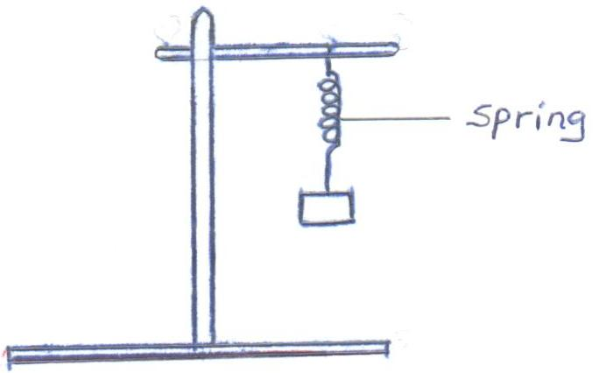
Fig. 1
Now give the mass a small vertical displacement and release so that it performs vertical oscillations. Time ten oscillations and determine the period T. Enter your results in table 1.

    - Repeat the experiment for the other values of mass and complete the table.
Table 1
Mass m (g) | 100 | 200 | 300
Time for 10 oscillations (s)
Periodic time T(s)
(3mks)
    - Given that T = π m , where k is the spring constant, find the average value k for the spring. K (2mks)

PART B
You are provided with the following:-
- A 250ml glass beaker
- A Bunsen burner
- A Thermometer
- A Stop watch
- A Tripod stand and a Wire gauze
- A measuring cylinder 100ml
- Water
Set the apparatus as shown in figure 2 below.
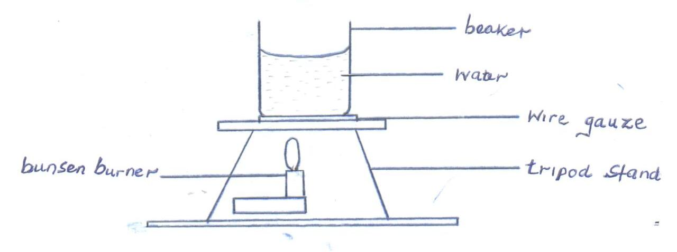
Fig. 2
    - Measure 100cm³ of water and pour it into the beaker. Take the initial temperature of the water.
T₀ = …………………………………………….⁰C (1mk)
Now heat the water to a temperature of 80⁰C. switch off the gas tap and place a thermometer into the beaker and start the stop watch when the temperature is 65⁰C. Take the temperature T⁰C of water ever two minutes. Record your results in the table 2 below.

Table 2
Time, t(min) | 2 | 4 | 6 | 8 | 10 | 12 | 14
Temperature (T) ⁰C
(T - T₀)
Log (T - T₀)
(5mks
    - Plot a graph of Log (T - T₀) against Time (t). (5mks)

- Find the value of P of log (T - T₀) when t = 0. (1mk)

- Determine N, where N is the antilog of P. (1mk)

- Calculate the temperature of the surrounding T_{R} using the expression N = 65–T_{R} (2mks)

